Building Taxation to Achieve the Millennium Development Goals in Africa
By Attiya Waris and Matti Kohonen

Table of Contents

Abstract 1
1. Introduction 2
2. Tax and Human Rights 4
2.1. The Right to Development, Taxation and State Responsibility 5
2.2. The African Context 6
3. Taxation in Africa and the MDGs 7
3.1. Data Analysis 7
32. Data 8
3.3. Tax and Millennium Development Goals in Africa 9
4. Conclusions 26
Annexes 27
Annex 1: Low-Income Countries in Africa 27
Annex 2: Countries according to their Tax per GDP ratio in 2003 27
Annex 3: Tax per GDP ratios for 2003 and MDG Achievement 2005-2008 in Africa 28

Abstract
The Millennium Development Goals (MDGs) are a critical step towards the progressive achievement of the most crucial human, social and economic rights. Many countries have made progress towards their achievement, but generally low-income countries in Africa are lagging behind. This paper will discuss how taxation could be added as a factor in both progress towards the MDGs, and their achievement in both progressive and absolute terms. The MDGs will be thus discussed in the context of all human, social and cultural rights.
In discussing tax or the MDGs there are many indices available. However although the still remains some challenge to prove whether there is a statistical correlation between tax and the MDGs, the debate is now beginning to move into the practicalities of the connections. Proving this relationship will be a major achievement for tax justice advocacy efforts, and we prefer to look at this relationship in all of its complexity as inevitably some indicators will show neutral or even opposite correlations. The proof of the test will, therefore, be in its robustness in comparison to other commonly used explanatory factors: exports per GDP, gross domestic product, or foreign direct investments.
The Centre for Global Development (CGD) in Washington published their MDG Progress Indicator Index for the MDG Review Summit in September 2005. The index has ranked countries with points in terms of the progress they have made in achieving their MDGs. Another way to combine different MDG indicators is to look at the Human Development Index (HDI) and the Human Poverty Index for developing countries (HPI-1). Both combine the aspects of a long and healthy life, knowledge, and a decent standard of living. The difference is that while the first includes GDP as one of the indirect measures of human well-being, the second does not. Using these sets of indices at a preliminary level this paper will explore the link between the indices to see if an additional connection can be built between tax collection and the achievement of the MDGs. Data will be used from the OECD/ADB African Economic Outlook 2010 database, in order to make statistical work towards this paper.

1. Introduction
The current global financial and economic crisis presents significant short-term risks to Africa’s progress toward achieving the MDGs by 2015. This combined with the continued rise in commodity prices due to high demand from emerging economies has increased the price of basic consumer items including wheat, rice and soya increasing the cost of living for many ordinary Africans who depend on food imports to meet their food consumption needs.

The goals of the Millennium Development Goals (1990-2015) that should be achievable by 2015 have been clearly set out as:
1. Eradicate extreme poverty and hunger
• Halve the proportion of people with less than one dollar a day.
• Halve the proportion of people who suffer from hunger.
2. Achieve universal primary education
• Ensure that boys and girls alike complete primary schooling.
3. Promote gender equality and empower women
• Eliminate gender disparity at all levels of education.
4. Reduce child mortality
• Reduce by two thirds the under-five mortality rate.
5. Improve maternal health
• Reduce by three quarters the maternal mortality ratio.
6. Combat HIV/AIDS, malaria and other diseases
• Reverse the spread of HIV/AIDS.
7. Ensure environmental sustainability
• Integrate sustainable development into country policies and reverse loss of environmental resources.
• Halve the proportion of people without access to potable water.
• Significantly improve the lives of at least 100 million slum dwellers.
8.Develop a global partnership for development
• Raise official development assistance.
• Expand market access.
• Encourage debt sustainability.

The rise of commodities has benefited the extractive industries, and some agricultural exporter companies in countries such as Kenya and South Africa, but this in turn has not sufficiently translated into tax revenues. Africa remains dependent on commodity exports, and the fall in 2008 which saw a brief fall in non-agricultural commodities, led to significant losses of revenues, along with corporate tax revenues and collection.
As a result, it has become much more volatile for consumers to pay for imported goods and for governments to finance critical infrastructure development with tax revenues. In short, even though trade will undoubtedly benefit developing countries by stimulating growth and reducing global poverty, reducing trade barriers is not sufficient to eliminate the need for domestic resource mobilisation principally in form of taxes in those countries with the largest MDG gap. Aid will remain important for the a group of the least developed countries, but the surprising result in the tax statistics is that tax has largely replaced aid for the best performing countries as a source of development financing.

To take advantage of market access, they require hefty investments in trade-creating infrastructure, transportation, and telecommunications, as well as investments in trade-related government institutions, such as better customs and tax administration, and overall management of public investment. These in turn require development assistance or “aid for trade”. This argument, however, misses a key factor in order to translate trade into public goods.
Exports

Consumption
Profits
Economic Activity
Corporate Tax
Public Expenditure through Taxation
MDG Achievements
Employment
Trade Tax
Private Consumption
Value Added Tax
Income Tax
Figure 1: MDG Achievement via Taxation

In this model it is assumed that tax revenues and public expenditure is the main manner in which MDG benefits are gained, rather than private consumption. The model does not consider non-tax revenues (such as royalties, earnings from state-owned corporations, administrative fees), nor does it look at state expenditure leakages (corruption, inefficient administrations), and it assumes that public expenditure is generally correctly allocated towards achieving MDG targets. We show here that also private consumption is a major manner in which MDG targets are being achieved, but it is not controlled here, and thus is assumed to be constant across African countries.

2. Tax and Human Rights

Studying a model where taxation is studied in relation to the achievement of human rights is essential towards their realisation. The declaration of human rights itself does not suffice for their realisation, and state building through the development of equitable tax systems is a necessary perquisite for achieving these very rights. The universality of social and economic rights have been analysed in the context of the Millennium Development Goals, and other poverty reduction papers, but none of these have so far explicitly discussed tax systems. It was rather through the UN Financing for Development (FfD) process that we have seen the introduction of tax systems into poverty reduction programmes, thus entailing a precedent in international treaties.

The 2008 United Nations Financing for Development (FfD) conference in Doha stated that:
‘We will step up efforts to enhance tax revenues through modernized tax systems, more efficient tax collection, broadening the tax base and effectively combating tax evasion. We will undertake these efforts with an overarching view to make tax systems more pro-poor. While each country is responsible for its tax system, it is important to support national efforts in these areas by strengthening technical assistance and enhancing international cooperation and participation in addressing international tax matters, including in the area of double taxation’. UN Financing for Development, Doha Declaration – article 16.
In seeking domestic resources to finance development it has been and is being argued that it would be more important to focus on tax rather than aid, as public domestic resources have far greater potential for collecting sufficient amounts of financing needed for social security.

Tax and aid, furthermore, are not mutually exclusive sources of development aid, but focused aid in areas where tax revenues are structurally weak, and in increasing technical and civil society capacity to tackle tax and public finances are being increasingly considered. It is also argued that this is greater in importance than planned debt relief, while again domestic resource mobilisation does not mean that debt relief and debt arbitration should be off the agenda. To trace the history of the UN FfD declaration, it's useful to look back at the broader human rights framework.

2.1. The Right to Development, Taxation and State Responsibility
In order to understand the theoretical link between rights and resources or perhaps the absence of the link between them, one must take a brief look at the history and development of human rights. In article 55 of the 1945 United Nations Charter states that:

With a view to the creation of conditions of stability and well-being which are necessary for peaceful and friendly relations among nations based on respect for the principle of equal rights and self-determination of peoples, the United Nations shall promote:
a. higher standards of living, full employment, and conditions of economic and social progress and development;

This initial statement was not met with statements towards how one should mobilise such resources, nor manners of international co-operation in the field of taxation to meet these objectives. In 1977, the United Nations Commission on Human Rights proclaimed the existence of the right to development. The right itself was eventually formulated in 1986 in the Declaration on the Right to Development (DRD). The DRD sets out critical obligations in its articles including state right and duty. It states at article 3 that

States have the right and the duty to formulate appropriate national development policies that aim at the constant improvement of the well-being of the entire population and of all individuals, on the basis of their active, free and meaningful participation in development and in the fair distribution of the benefits resulting therefrom.

This entails three important basic principles. Firstly, that it is the primary responsibility of states to apply policies aimed at improving the well-being of the population, secondly, that the human person is the central subject and should be the active participant and finally that there should be distribution of benefits.

In addition the DRD went one step further and placed the responsibility of the realisation of the right to development not only on individual states in consideration of their populations but also on states collectively for all peoples. Article 4 states that:

States have the duty to take steps, individually and collectively, to formulate international development policies with a view to facilitating the full realization of the right to development.

An important development that is marked by these two provisions was that the DRD through these articles clearly articulates that it is the state’s obligation to implement the right. Thus, the realisation of the right to development requires states to link resource allocation to human rights. This link was only created in the Monterrey Financing for Development declaration in 2002, and rearticulated in the Doha Financing for Development process in 2008.

2.2. The African Context
The only international treaty that expressly recognises the right to development and is the African Charter of Human and Peoples Rights, which came into effect in 1984, binds it member states. This has resulted in the inclusion of this right in more recently drafted constitutions like that of Benin including it in their bill of rights. This Banjul declaration, and the subsequent court for human and people's rights established enshrines this in practice.

In 1995 the world embraced significance of well-being and development for all, however, states have neither absorbed this right into their constitutions nor have they with a few exceptions, declared this as a human right.

From the perspective of the Schumpeter’s typology of fiscal states, the fiscal state’s levels of development achieved include provision of a diverse array of social welfare benefits to their citizens and as a result the state perceives no additional rational in adding a constitutional provision for an issue already well settled in state-society relations. However for the post-colonial fiscal state this need for the recognition of the developmental needs of their citizens is necessary in order to provide better guidelines for the resource uses of the state.

The Millennium Development Goals (MDGs) are a critical step towards the progressive achievement of the most crucial human, social and economic rights. Many countries have made progress towards their achievement, but generally low-income countries in Africa are lagging behind. This paper will discuss how taxation could be studied as a factor in both progress towards the MDGs, and their achievement in both progressive and absolute terms. The Millennium Development Goals (MDGs) are a critical towards the progressive achievement of the most crucial human, social and economic rights.

Despite these criticisms, the need for international co-operation was recognised and the existence of state obligations to co-operate in order to realise the right to development, there developed various instruments allowing for co-operation. These included international economic co-operation in the form of overseas development assistance or foreign aid; access to markets through trade liberalisation; incentives to increase investment flows and technology transfer; bilateral and multilateral assistance to implement structural adjustments and economic reforms; debt forgiveness and assisting countries to meet financial crises. However, these strategies have come under heavy criticism as being oriented towards economic growth and macroeconomic stability, which as it doesn't explicitly consider human rights indirectly results in human rights violations.

There has also been the development of measures with which states can analyse their realisation of human rights these include the use of approached like Amartya Sen’s capability approach, Nussbaum's basic needs proposal, human development, human poverty and well-being indicators and the Millennium Development Goals which set benchmarks that allow for the realisation of human rights while taking into consideration the resource constraints that states face.

In addition, global organizations that are formally or informally linked to other organizations, agencies, and governments around the world, such as the United Nations and the World Bank, view citizens' participation in claiming their rights and budgetary design practices as a crucial part of their responsibility to improve their well-being. In addition, more recent endeavours have begun within the United Nations to analysing how fiscal policies and budgets can be converted in order to realise human rights.

3. Taxation in Africa and the MDGs
This study empirically analysed the statistical possibilities of the relations between tax and human rights. It utilises data collected by the African Development Bank (ADB), and it goes as far back as 1996 and up to 2008, data for 2009 came available in March 2011, but was not included in the study as the statistical analysis was done prior to this. The relationship is new as data is only recently available on African Tax per GDP ratios on a reliable manner due to this survey, as previous IMF and World Bank statistical sets had significant gaps. In this study, only the Tax per GDP ratio is being studies, leaving out non-tax revenues for the time being (including oil and gas revenues).

3.1. Data Analysis
Figure 3 plots the taxes (direct, indirect, trade, source: OECD&ADB) against GDP (in current US dollars), by country and year. Tax groups were created on the basis of this variable for 2003 mainly because we assumed a five-year lag before the effects of taxes are realised to correlate with the MDG data for the latest available year between 2006-2008. Also, 2003 had the best availability of tax data for all countries. We could have chosen also the average between 1996-2008, but the year 2003 was a satisfactory single year of comparison.

Table 1: Table of States Grouped on the Basis of Tax/GDP Ratio
Tax group number | Taxes/GDP in 2003 | Number of countries
1 | 0-10% | 16
2 | 10-15% | 19
3 | 15-20% | 9
4 | 20%+ | 7

Source: ADB/OECD

The relationship became clearer when we divided African countries into four groups according to their tax per GDP ratio. Placing the base year for the tax per GDP at 2003, and assuming a time lag of 3-5 years from levying taxes to results in specific targets. The latest statistics of MDG achievement used are from 2005-2008. The result was clear: most indicators show a positive relationship, with the notable exception of diseases.

32. Data
Based upon AEO Country survey data and the African Development Bank's Statistical department this dataset includes 53 African countries. However, there is no data for Somalia and only a very limited coverage and low-quality data for Zimbabwe. We therefore exclude these two countries from the analysis and consider 51 countries for which we have most tax data for the period 1996 to 2008. The dataset had estimates 2009 and some predictions for 2010 and 2011, but we have restrained from using them because of their presumed quality as was suggested by the ADB and the OECD who had compiled the tax data.

In discussing tax or the MDGs there are many indices available however the challenge remains to prove whether there is a correlation between tax and the MDGs. The Centre for Global Development MDG Progress Indicator Index has ranked countries with points in terms of the progress they have made in achieving their MDGs. In figure 2 we study the relationship for low-income countries in Africa in relation to the most up-to-data tax per GDP data, which includes the components of direct, indirect and trade taxes.

The Human Poverty Index for developing countries (HPI-1), and the Human Development Index (HDI) combine the aspects of a long and healthy life, knowledge, and a decent standard of living. Using these sets of indices at a preliminary level we linked the indices to see if there can be a link to be built between tax collection and the achievement of the MDGs. We find that there is indeed a relationship. However, while for the entire group of African countries the relationship was weaker, notably due to some outliers, for low-income countries the relationship is strong.

3.3. Tax and Millennium Development Goals in Africa

Many countries have made progress towards their achievement, but generally low-income countries in Africa are lagging behind. Here we look at how taxation should be studied as a factor in both progress towards the goals, and achievement in absolute terms.

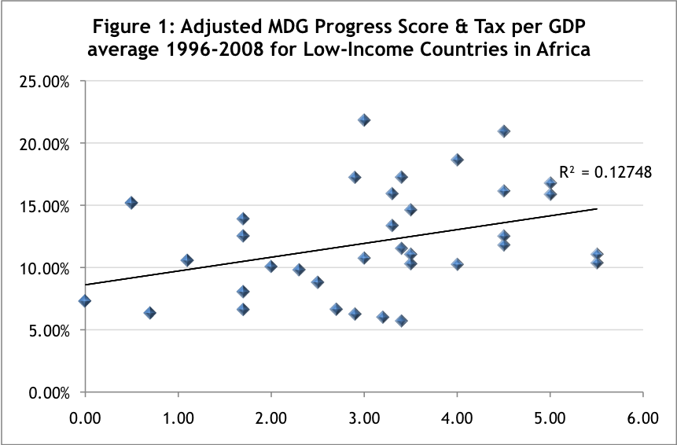
Source: Tax Justice Network

The Centre for Global Development MDG Progress Indicator Index has ranked countries with points in terms of the progress they have made in achieving their MDGs. In Figure 1 we study the relationship for low-income countries in Africa (See Annex 1) in relation to the most up-to-data tax per GDP data, which includes the components of direct, indirect and trade taxes.

The Human Poverty Index for developing countries (HPI-1), and the Human Development Index (HDI) combine the aspects of a long and healthy life, knowledge, and a decent standard of living. While for the entire group of African countries the relationship was weaker, notably due to some outliers, for low-income countries the relationship is strong.

The figures 2-5 include an analysis of the relationship between tax and human development, both showing significant correlation with a higher tax per GDP ratio. This finding is significant, as it shows that it is not GDP or volumes of aid as such which determines a country's MDG achievements, but it is the capacity of the country to tax these operations effectively and equitably, which yields tangible MDG achievements.

The message is quite clear, both extractive and non-extractive countries should focus on increasing their tax base and actual tax revenues as a share of GDP. Fostering the development of a non-extractive economy is important for the low-tax per GDP countries, as extractives do not have such a clear MDG impact in their current climate due to price volatility, narrow interest group base of, associated corruption and finally often lack of attention paid to the non-extractive economy where most of the citizens actually live and work.

How to make extractive industries actually beneficial to the citizens in Africa requires further attention to diversifying the economy, and the associated tax base away from extractive industries which tend to benefit only very narrow interest groups, and provide only very limited opportunities for employment and incomes. A broad tax base means broader representation of citizens in revenue bargaining and budget dialogue, as it is often the case that she who pays the budget has more say in its use.

Further statistical work would be required for the lower-middle and middle-income countries in Africa, to better understand the relationships between extractives and the tax per GDP ratio, as there were two outliers in both groups (Swaziland and Lesotho) with exceptionally high trade tax shares bringing their tax per GP ratios as high as 37.2% and 43.4% respectively. The grouping of countries in the four groups in figures 6-17 normalises this variation.

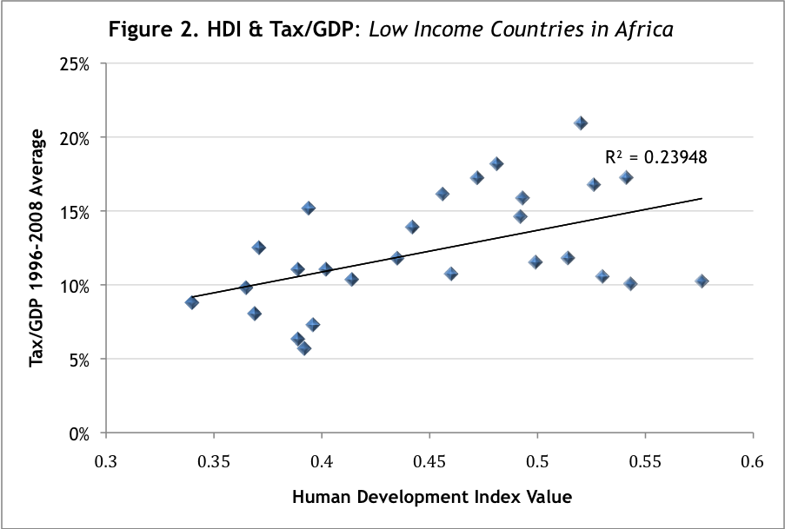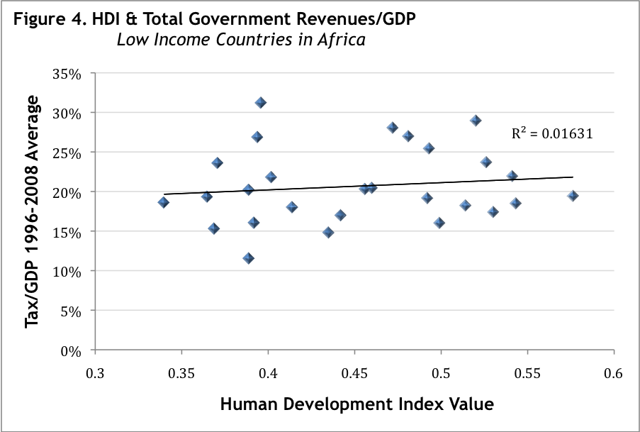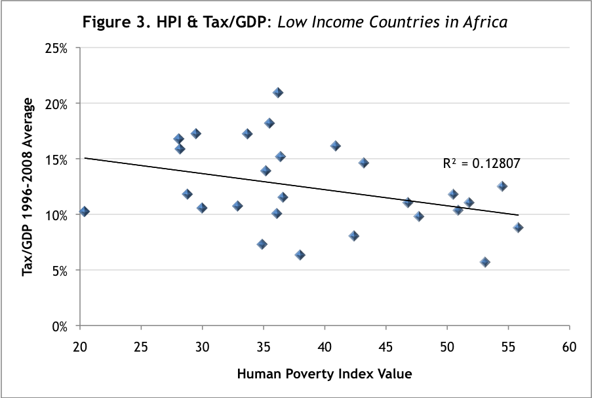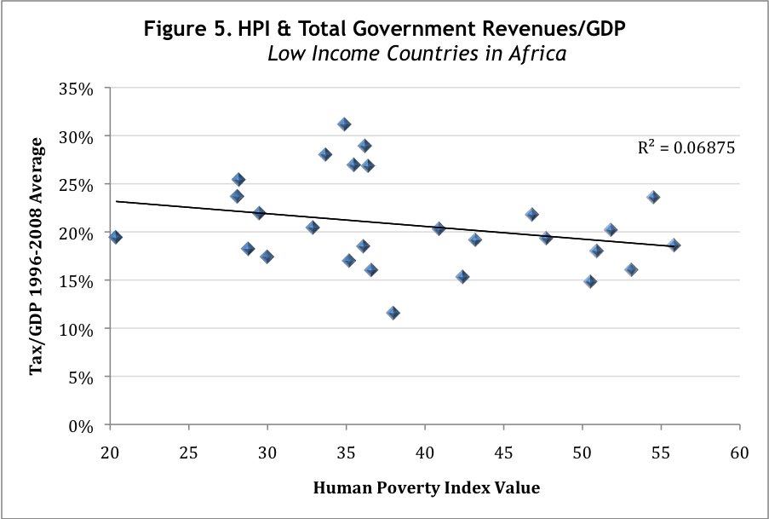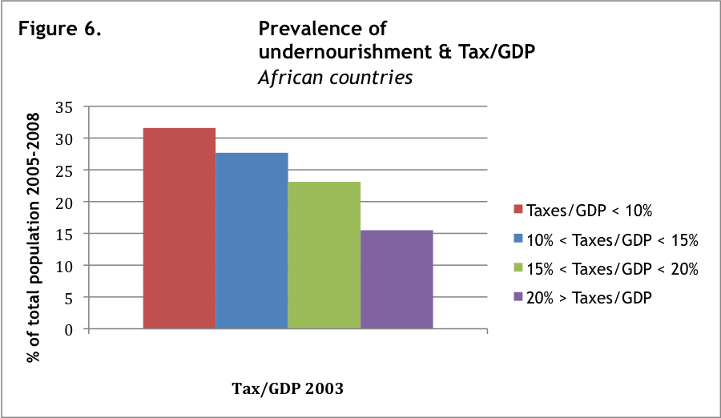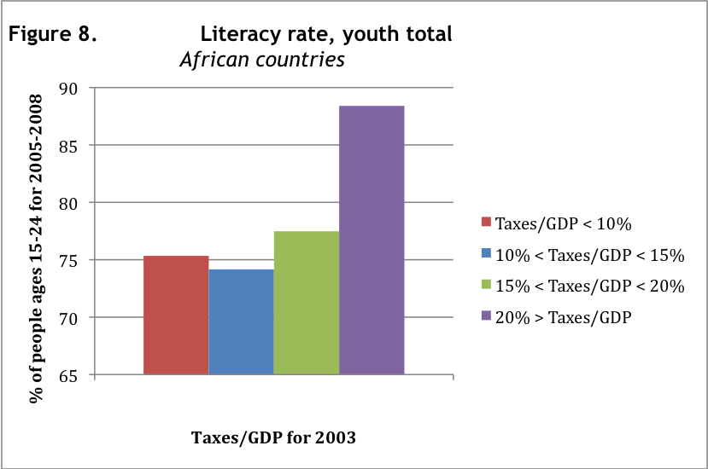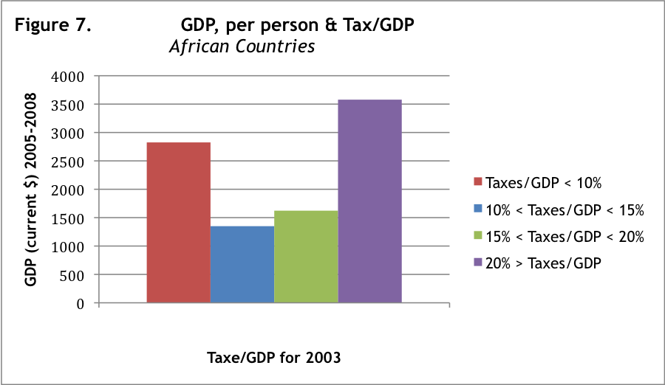
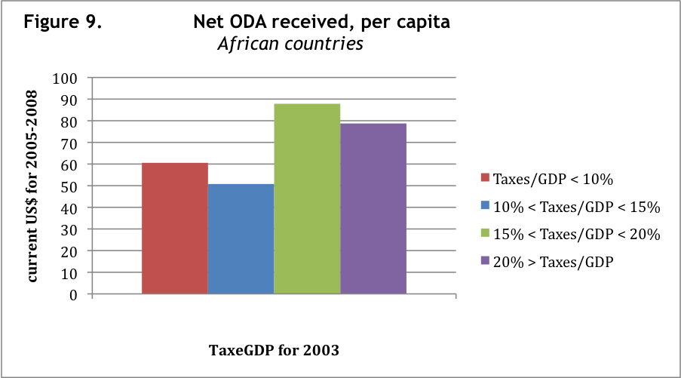
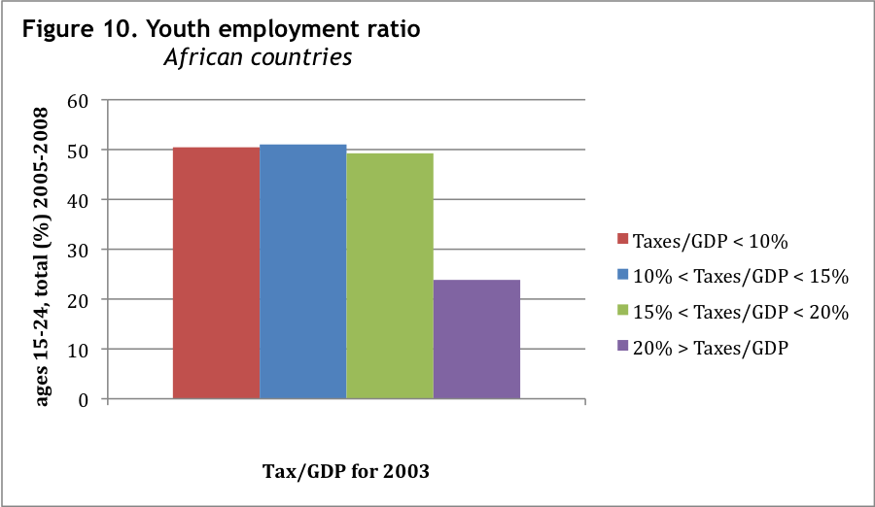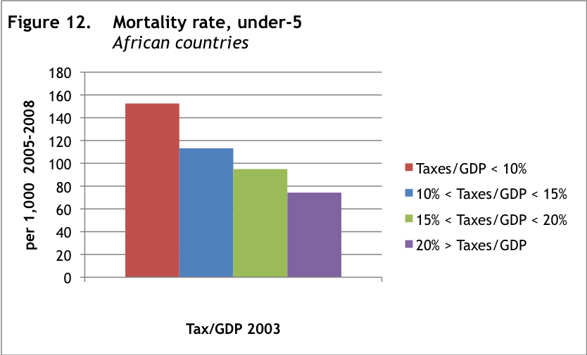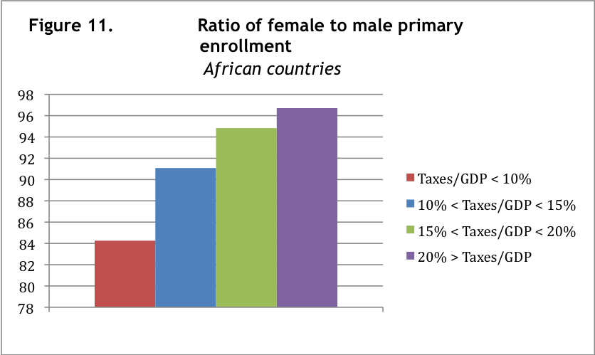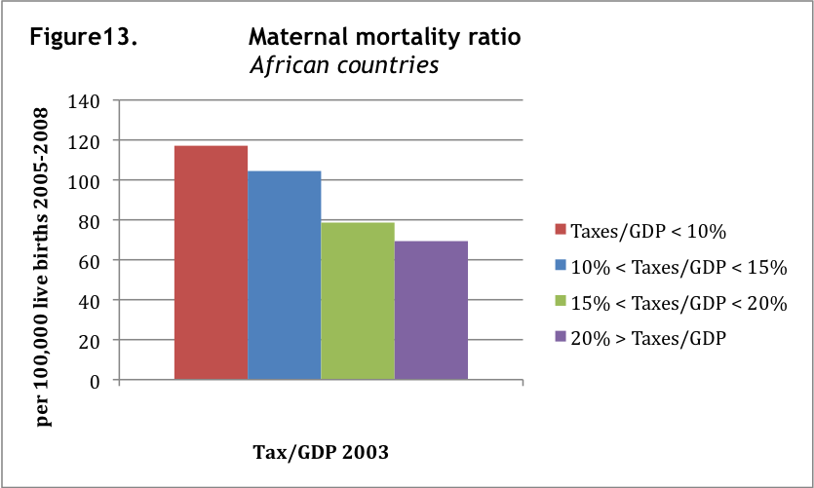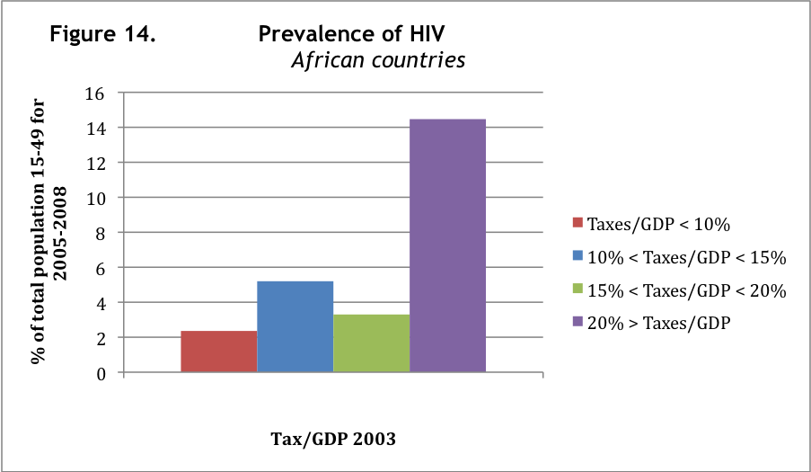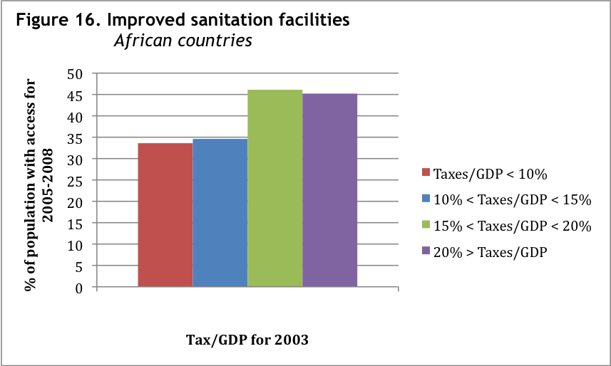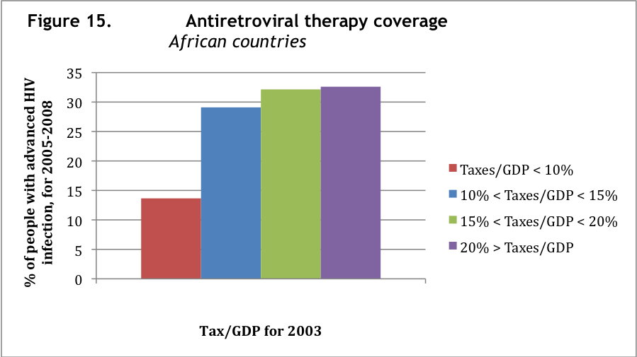
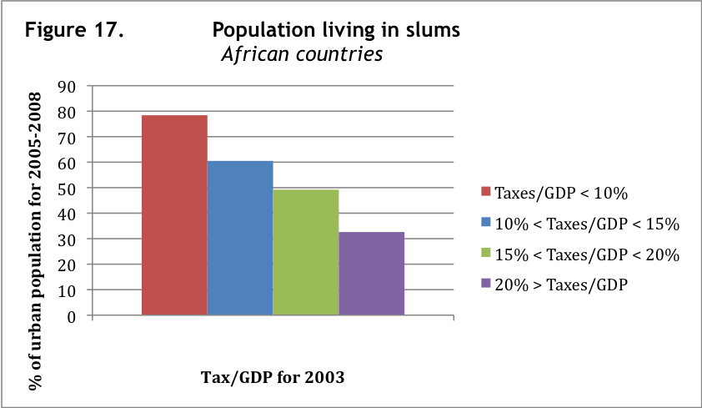
The relationship is also clear when African countries are divided in four groups according to their tax per GDP ratio (See Annex 2). The basis year for the tax per GDP at 2003, assuming a time lag of 3-5 years from levying taxes to results in specific targets. The latest statistics of MDG achievement are from 2005-2008.

The results show across the board that the tax per GDP ratio is a significant factor towards the achievement of MDG goals. Even more significant is that it beheaves very differently from the GDP (as seen in figure 7) as well as aid (as seen in figure 8), making the case that tax is an independent variable worth discussing along side with these two common explanations for the successful achievement of MDG targets.

Second issue worth noting is that we are talking of a relative ratio, rather than an absolute investment in each of the areas. This means that the relative sums of money in relation to GDP or we could have also studied in relation to the overall budget, is interesting as salary levels and other costs associated in achieving MDG targets tend to vary in relation to GDP. Achieving MDGs is about the relative importance the country in question gives towards achieving them, rather than just the money spent towards the targets in absolute terms.

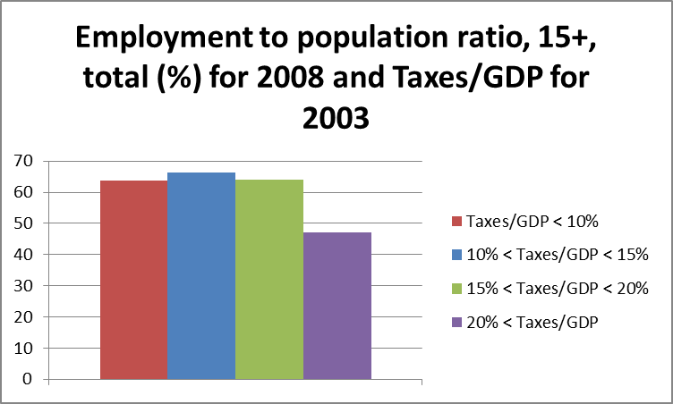

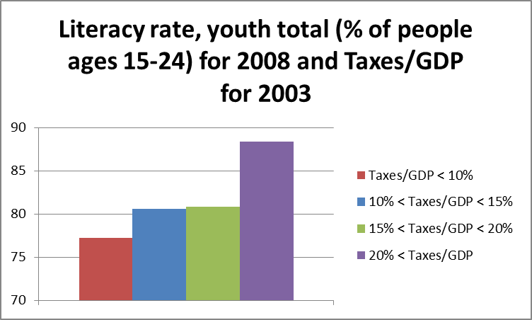

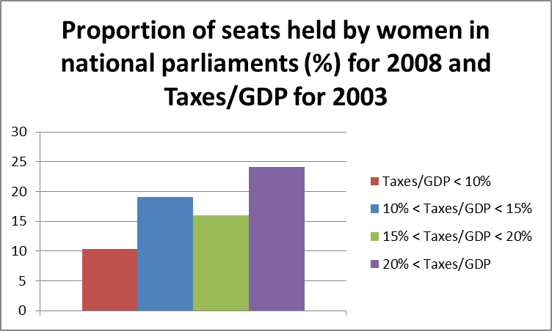

The proportion of women holding parliamentary seats has risen in Sub-Saharan Africa from an average of 8 to 18 between 1990 and 2008; and from 2 to 9 in North Africa, countries with a high tax per GDP ratio perform the best, equally well as developed nations in 2010, this too somewhat correlated with the country's tax per GDP ratio, as can be noted in Annex 3. Other gender indicators related more closely, such as gender parity in accessing primary education.

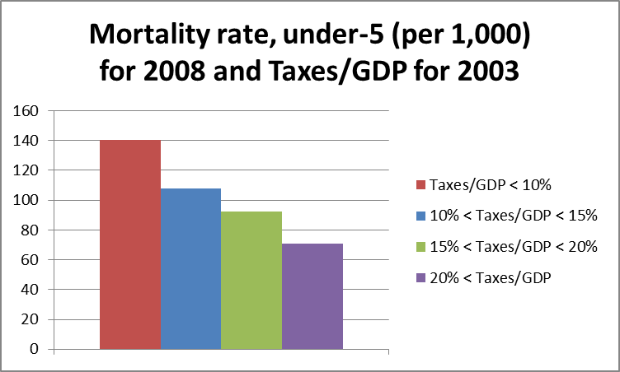

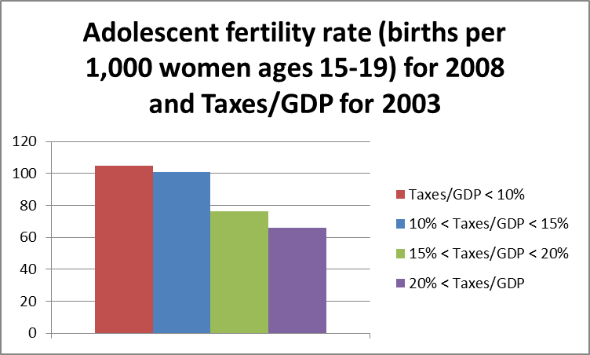

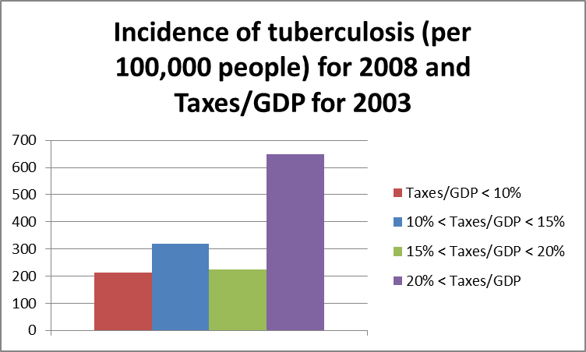

The prevalence of HIV / AIDS, which is highest in the countries of Southern Africa which are predominantly in the over 20% group of countries, which explains the reason the relationship is this case is actually inverse to what we would expect. The explanations towards the higher HIV/AIDS prevalence are to be sought elsewhere from the relative importance of taxation, and taxes do provide resources in these countries with higher tax per GDP for anti-retroviral drug treatments to be more commonplace than elsewhere.

In some cases, including sanitation and literacy the investments seem to pay off after a certain threshold, an issue which would need to be checked from other sources as well in the issue-specific literature. In sanitation, figure 16, there was a significant increase in the above 15% tax per GDP group. Literacy rate, figure 8, only has a significant change in the over 20% tax per GDP group, and similarly youth employment ratio also only drops in the over 20% group, most likely due to the availability of professional and university educational opportunities in these countries.

Based on this limited study, it's not easy to make recommendations apart from stating that further research is required in better understanding this relationship. Clear recommendations should follow from a much wider statistical study, which eliminates other possible factors such as private consumption (included in the model but not controlled), as well as extractive industry influences further. Their exclusion was made on a very general level, not on an indicator-by-indicator level. Indeed extractive industries are likely in positive circumstances to contribute towards some of the MDG achievements, thought their overall influence is considered to be negative at least in the least developed countries as studied above.

The tables on the progression of tax revenues are also interesting. Here we see that in the last 15 years in Africa it has been mainly the increasing resource revenues which have doubled from 3.5% of GDP to 7% of GDP in the period. Meanwhile tax revenues overall have increased much less, from 13% of GDP to 14.5% of GDP. Debt relief in 2006 gave a significant boos to development aid grants, but the levels of aid have since returned to their historical levels of 4% of GDP, significant but not enough to meet the MDG targets. Direct taxes have only increased very slightly, where as trade taxes have actually decreased and been replaced by indirect taxes.

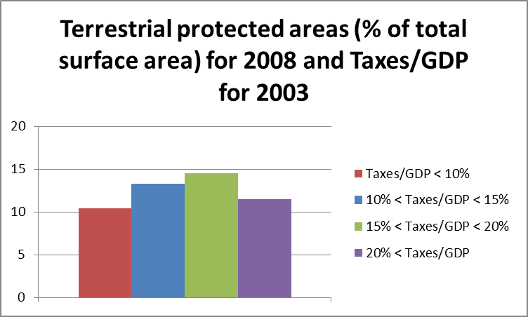

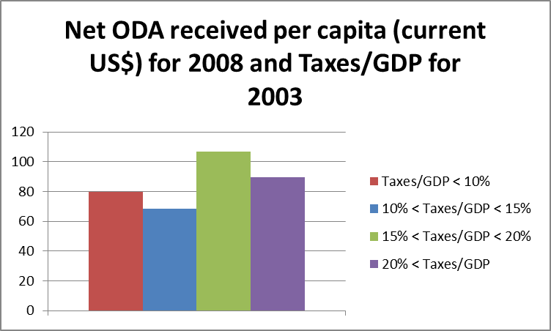

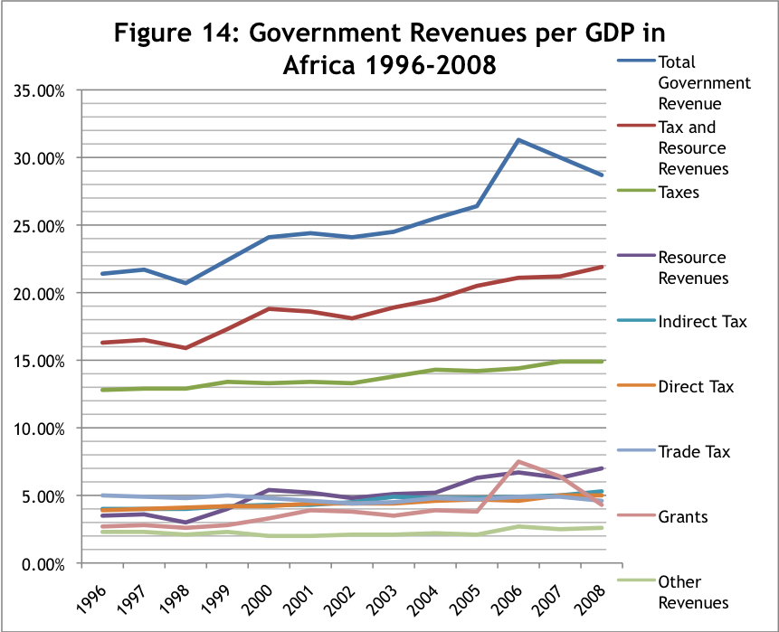
Source: Tax Justice Network

4. Conclusions

Tax systems in Africa are key to the achievement of Millennium Development Goals by the year 2015. Accelerating domestic resource mobilisation to finance the MDGs is the seventh agenda point of the 2000- 2015 MDG Action Agenda, but it is also the least discussed in terms of solutions. The MDG monitoring framework should consider taxation, for instance, knowing the share of aid that is spent on tax co-operation.

Much more research is needed to better understand the relationship, but the results themselves point out that the relationship is strong and an interesting one to consider in terms of the developmental outcomes. The authors hope to engage with both civil society and policy makers in order to better advance the understanding of the relationship between tax and human rights, within the MDG targets and beyond.

Annexes

Annex 1: Low-Income Countries in Africa

Benin, Burkina Faso, Burundi, Central African Republic, Chad
Comoros, Congo, Dem. Rep. of, Eritrea, Ethiopia, Gambia, Ghana, Guinea, Guinea-Bissau, Kenya, Liberia, Madagascar, Malawi, Mali, Mauritania, Mozambique, Niger, Rwanda, Sierra Leone, Tanzania, Togo, Uganda, Zambia

Annex 2: Countries according to their Tax per GDP ratio in 2003

(Somalia and Zimbabwe were excluded due to data access regarding taxation)

Tax per GDP | <10%  (n=16) | 10%-15% (n=19) | 15%-20%  (n=9) | >20%  (n=7)
Country | Algeria, Angola, Central African Republic, Chad, Comoros, Democratic Republic of Congo, Republic of Congo, Equatorial Guinea, Guinea-Bissau, Liberia, Libya, Madagascar, Niger, Nigeria, Sudan,  Sao Tome and Principe | Botswana, Burkina Faso, Cameroon, Côte d’Ivoire, Egypt, Eritrea, Ethiopia, Gabon, Gambia, Guinea, Malawi,  Mali, Mozambique, Rwanda, Sierra Leone, Tanzania, Togo, Tunisia, Uganda | Benin, Burundi, Cape Verde, Ghana, Kenya, Mauritius,  Morocco, Senegal, Zambia | Djibouti, Lesotho, Mauritania, Namibia, Seychelles, South Africa, Swaziland

Annex 3: Tax per GDP ratios for 2003 and MDG Achievement 2005-2008 in Africa

Group / Year | 2005 | 2006 | 2007 | 2008 | 2005 | 2006 | 2007 | 2008 | Average | N
Goal 1: Eradicate Extreme Poverty and Hunger
Prevalence of undernourishment (% of population)
<10% | - | 31,58 | - | - | - | 12 | - | - | 31,58 | 12
10%-15% | - | 27,68 | - | - | - | 15 | - | - | 27,68 | 15
15%-20% | - | 23,11 | - | - | - | 8 | - | - | 23,11 | 8
>20% | - | 15,50 | - | - | - | 6 | - | - | 15,50 | 6
Employment to population ratio, ages 15-24, female (%)
<10% | 41,2 | 43,5 | 42,5 | 41,2 | 13 | 14 | 13 | 15 | 42,1 | 55
10%-15% | 47,2 | 47,3 | 47,3 | 47,3 | 19 | 19 | 19 | 19 | 47,3 | 76
15%-20% | 42,3 | 42,4 | 42,5 | 42,5 | 9 | 9 | 9 | 9 | 42,4 | 36
>20% | 20,8 | 21,8 | 21,2 | 20,9 | 5 | 5 | 5 | 5 | 21,2 | 20
Employment to population ratio, ages 15-24, male (%)
<10% | 58,7 | 59,6 | 59,7 | 57,8 | 13 | 14 | 13 | 15 | 59,0 | 55
10%-15% | 55 | 54,7 | 54,7 | 54,4 | 19 | 19 | 19 | 19 | 54,7 | 76
15%-20% | 56,6 | 56 | 56 | 55,6 | 9 | 9 | 9 | 9 | 56,1 | 36
>20% | 26,4 | 27,2 | 26,6 | 26 | 5 | 5 | 5 | 5 | 26,6 | 20
Employment to population ratio, ages 15-24, total (%)
<10% | 49,9 | 51,5 | 51 | 49,5 | 13 | 14 | 13 | 15 | 50,5 | 55
10%-15% | 51,1 | 51,1 | 51 | 50,9 | 19 | 19 | 19 | 19 | 51,0 | 76
15%-20% | 49,5 | 49,2 | 49,2 | 49,1 | 9 | 9 | 9 | 9 | 49,3 | 36
>20% | 23,6 | 24,4 | 23,9 | 23,5 | 5 | 5 | 5 | 5 | 23,9 | 20
Employment to population ratio, 15+, female (%)
<10% | 49,2 | 51,7 | 50,1 | 49,8 | 13 | 14 | 13 | 15 | 50,2 | 55
10%-15% | 57,4 | 57,8 | 57,8 | 57,9 | 19 | 19 | 19 | 19 | 57,7 | 76
15%-20% | 53,4 | 53,6 | 53,8 | 54 | 9 | 9 | 9 | 9 | 53,7 | 36
>20% | 40,6 | 42,2 | 41,9 | 41,8 | 5 | 5 | 5 | 5 | 41,6 | 20
Employment to population ratio, 15+, male (%)
<10% | 77,6 | 78,3 | 78,6 | 77,8 | 13 | 14 | 13 | 15 | 78,1 | 55
10%-15% | 74,3 | 74,4 | 74,6 | 74,5 | 19 | 19 | 19 | 19 | 74,5 | 76
15%-20% | 74,9 | 74,7 | 74,8 | 74,7 | 9 | 9 | 9 | 9 | 74,8 | 36
>20% | 52,4 | 53,6 | 53,5 | 53 | 5 | 5 | 5 | 5 | 53,1 | 20
Employment to population ratio, 15+, total (%)
<10% | 63,1 | 64,8 | 64,2 | 63,7 | 13 | 14 | 13 | 15 | 64,0 | 55
10%-15% | 65,8 | 66 | 66,1 | 66,2 | 19 | 19 | 19 | 19 | 66,0 | 76
15%-20% | 63,8 | 63,9 | 64 | 64,1 | 9 | 9 | 9 | 9 | 64,0 | 36
>20% | 46,2 | 47,6 | 47,4 | 47,1 | 5 | 5 | 5 | 5 | 47,1 | 20
Goal 2: Achieve Universal Primary Education
Literacy rate, youth total (% of people ages 15-24)
<10% | 36,5 | 91,8 |  | 77,2 | 1 | 1 | 0 | 12 | 68,5 | 14
10%-15% | 58,9 | 61,8 | 39,3 | 80,6 | 2 | 2 | 1 | 14 | 42,1 | 19
15%-20% | - | 50,9 |  | 80,8 | 0 | 1 | 0 | 8 | 65,9 | 9
>20% | - | - | - | 88,4 | 0 | 0 | 0 | 5 | 88,4 | 5
Primary completion rate, total (% of relevant age group)
<10% | 51,4 | 48,7 | 49 | 62,8 | 8 | 6 | 8 | 9 | 42,1 | 31
10%-15% | 61,3 | 59,5 | 62,5 | 56,1 | 15 | 14 | 16 | 11 | 59,9 | 56
15%-20% | 74,1 | 73,2 | 75,1 | 75,7 | 8 | 8 | 8 | 9 | 74,5 | 33
>20% | 70,9 | 65,3 | 81 | 62 | 7 | 6 | 6 | 3 | 69,8 | 22
School enrolment, primary (% net)
<10% | 63,1 | 68,6 | 65,4 | 75,1 | 4 | 6 | 4 | 4 | 68,1 | 18
10%-15% | 75,1 | 76,2 | 77,8 | 78,3 | 14 | 13 | 12 | 12 | 76,9 | 51
15%-20% | 79,8 | 82,1 | 85 | 87 | 9 | 9 | 8 | 9 | 83,5 | 35
>20% | 72,9 | 74 | 75,4 | 67,1 | 6 | 6 | 6 | 2 | 72,4 | 20
Goal 3: Promote Gender Equality and Empower Women
Ratio of female to male primary enrolment (%)
<10% | 83,2 | 83,6 | 83,7 | 86,3 | 9 | 9 | 9 | 10 | 84,2 | 37
10%-15% | 90,7 | 91 | 91,2 | 91,5 | 16 | 17 | 17 | 13 | 91,1 | 63
15%-20% | 92,7 | 94,5 | 96,5 | 95,8 | 9 | 9 | 8 | 9 | 94,9 | 35
>20% | 96,8 | 95,8 | 96,8 | 98,1 | 7 | 6 | 7 | 3 | 96,9 | 23
Proportion of seats held by women in national parliaments (%)
<10% | 10,8 | 10,2 | 11,2 | 10,4 | 12 | 14 | 13 | 16 | 10,7 | 55
10%-15% | 17,1 | 18 | 18,3 | 19,1 | 19 | 19 | 19 | 19 | 18,1 | 76
15%-20% | 12,8 | 14,8 | 15,2 | 16 | 9 | 9 | 9 | 9 | 14,7 | 36
>20% | 20,4 | 20,4 | 20,9 | 24,1 | 6 | 6 | 7 | 6 | 21,5 | 25
Goal 4: Reduce Child Mortality
Mortality rate, under-5 (per 1,000)
<10% | 160,9 | 155,8 | 155,7 | 140,2 | 13 | 14 | 13 | 16 | 153,2 | 56
10%-15% | 119 | 114,9 | 111,2 | 107,8 | 19 | 19 | 19 | 19 | 113,2 | 76
15%-20% | 97,8 | 95,8 | 93,9 | 92,3 | 9 | 9 | 9 | 9 | 95,0 | 36
>20% | 78,7 | 75 | 72,7 | 70,8 | 7 | 7 | 7 | 7 | 74,3 | 28
Mortality rate, infant (per 1,000 live births)
<10% | 98,1 | 95,2 | 94 | 86,5 | 13 | 14 | 13 | 16 | 93,5 | 56
10%-15% | 76,2 | 73,8 | 71,7 | 69,7 | 19 | 19 | 19 | 19 | 72,9 | 76
15%-20% | 62 | 60,9 | 59,8 | 58,9 | 9 | 9 | 9 | 9 | 60,4 | 36
>20% | 56,6 | 54,4 | 53 | 51,8 | 7 | 7 | 7 | 7 | 54,0 | 28
Goal 5: Improve Maternal Health
Maternal mortality ratio (modelled estimate, per 100,000 live births)
<10% | 971,5 | - | - | - | 13 | 0 | 0 | 0 | 971,5 | 13
10%-15% | 758,4 | - | - | - | 19 | 0 | 0 | 0 | 758,4 | 19
15%-20% | 592,8 | - | - | - | 9 | 0 | 0 | 0 | 592,8 | 9
>20% | 571,7 | - | - | - | 6 | 0 | 0 | 0 | 571,7 | 6
Adolescent fertility rate (births per 1,000 women ages 15-19)
<10% | 122,5 | 120,8 | 123 | 104,7 | 13 | 14 | 13 | 16 | 117,8 | 56
10%-15% | 107,9 | 105,6 | 103,4 | 100,9 | 19 | 19 | 19 | 19 | 104,5 | 76
15%-20% | 80,6 | 79,3 | 78,1 | 76,5 | 9 | 9 | 9 | 9 | 78,6 | 36
>20% | 72,6 | 70,5 | 68,4 | 65,9 | 6 | 6 | 6 | 6 | 69,4 | 24
Goal 6: Combat HIV/AIDS, Malaria and Other Disease
Prevalence of HIV, total (% of population ages 15-49)
<10% | 2,4 | 2,2 | 2,5 | - | 12 | 13 | 11 | 0 | 2,4 | 36
10%-15% | 5,3 | 5,2 | 5,1 | - | 18 | 18 | 18 | 0 | 5,2 | 54
15%-20% | 3,3 | 3,3 | 3,3 | - | 7 | 7 | 7 | 0 | 3,3 | 21
>20% | 14,5 | 14,5 | 14,4 | - | 6 | 6 | 6 | 0 | 14,5 | 18
Antiretroviral therapy coverage, (% of people with advanced HIV infection)
<10% | - | 10,2 | 17,4 | - | 0 | 13 | 12 | 0 | 13,8 | 25
10%-15% | - | 26,2 | 32 | - | 0 | 19 | 19 | 0 | 29,1 | 38
15%-20% | - | 29,3 | 35 | - | 0 | 8 | 8 | 0 | 32,2 | 16
>20% | - | 28 | 37,2 | - | 0 | 6 | 6 | 0 | 32,6 | 12
Tuberculosis case detection rate (all forms)
<10% | 49,6 | 56,2 | 63 | 62,2 | 12 | 12 | 9 | 16 | 57,8 | 49
10%-15% | 44,9 | 44 | 45,2 | 45,8 | 19 | 19 | 19 | 19 | 45,0 | 76
15%-20% | 47,6 | 47,8 | 47,5 | 49,3 | 9 | 9 | 8 | 9 | 48,1 | 35
>20% | 62,4 | 66,9 | 56,1 | 61 | 7 | 6 | 6 | 7 | 61,6 | 26
Incidence of tuberculosis (per 100,000 people)
<10% | 248,5 | 246,1 | 257,8 | 212,2 | 12 | 13 | 12 | 16 | 241,2 | 53
10%-15% | 321,2 | 319,8 | 318,8 | 318,7 | 19 | 19 | 19 | 19 | 319,6 | 76
15%-20% | 247,9 | 238,5 | 231,2 | 223,5 | 9 | 9 | 9 | 9 | 235,3 | 36
>20% | 638,7 | 642,6 | 645,6 | 649,2 | 7 | 7 | 7 | 7 | 644,0 | 28
Tuberculosis treatment success rate (% of registered cases)
<10% | 73,2 | 68,2 | 74,1 | - | 11 | 9 | 11 | 0 | 107,8 | 31
10%-15% | 76,4 | 76,6 | 79 | - | 19 | 19 | 18 | 0 | 77,3 | 56
15%-20% | 79,1 | 82,7 | 84,5 | - | 9 | 8 | 7 | 0 | 82,1 | 24
>20% | 65,9 | 62,9 | 74 | - | 6 | 6 | 7 | 0 | 67,6 | 19
Tuberculosis death rate (per 100,000 people)
<10% | 63,1 | 59,4 | 64,6 | - | 13 | 14 | 13 | 0 | 62,4 | 40
10%-15% | 88,1 | 87,9 | 86,7 | - | 19 | 19 | 19 | 0 | 87,6 | 57
15%-20% | 57 | 53,8 | 51,1 | - | 9 | 9 | 9 | 0 | 54,0 | 27
>20% | 145,8 | 142,4 | 164,2 | - | 7 | 7 | 7 | 0 | 150,8 | 21
Goal 7: Ensure Environmental Sustainability
Forest area (sq. km)
<10% | 260693,5 | 250044,3 | 266359,6 | - | 13 | 14 | 13 | 0 | 259032,5 | 40
10%-15% | 90933,9 | 9029,7 | 89663,3 | - | 19 | 19 | 19 | 0 | 63209,0 | 57
15%-20% | 74613,1 | 73853,6 | 73093,7 | - | 9 | 9 | 9 | 0 | 73853,5 | 27
>20% | 25322,3 | 25208,7 | 25095,1 | - | 7 | 7 | 7 | 0 | 25208,7 | 21
Forest area (% of land area)
<10% | 32,9 | 32 | 33,9 | - | 13 | 14 | 13 | 0 | 32,9 | 40
10%-15% | 26,9 | 26,9 | 26,8 | - | 19 | 19 | 19 | 0 | 26,9 | 57
15%-20% | 23,2 | 22,9 | 22,7 | - | 9 | 9 | 9 | 0 | 22,9 | 27
>20% | 19,4 | 19,5 | 19,5 | - | 7 | 7 | 7 | 0 | 19,5 | 21
Terrestrial protected areas (% of total surface area)
<10% | - | - | - | 10,4 | 0 | 0 | 0 | 14 | 10,4 | 14
10%-15% | - | - | - | 13,3 | 0 | 0 | 0 | 19 | 13,3 | 19
15%-20% | - | - | - | 14,5 | 0 | 0 | 0 | 9 | 14,5 | 9
>20% | - | - | - | 11,5 | 0 | 0 | 0 | 7 | 11,5 | 7
Marine protected areas (% of total surface area)
<10% | - | - | - | 4,2 | 0 | 0 | 0 | 15 | 4,2 | 15
10%-15% | - | - | - | 1,7 | 0 | 0 | 0 | 19 | 1,7 | 19
15%-20% | - | - | - | 2,3 | 0 | 0 | 0 | 9 | 2,3 | 9
>20% | - | - | - | 5,5 | 0 | 0 | 0 | 7 | 5,5 | 7
Improved water source (% of population with access)
<10% | - | 58,7 | - | - | 0 | 14 | 0 | 0 | 58,7 | 14
10%-15% | - | 70 | - | - | 0 | 19 | 0 | 0 | 70 | 19
15%-20% | - | 73,9 | - | - | 0 | 8 | 0 | 0 | 73,9 | 8
>20% | - | 79,3 | - | - | 0 | 6 | 0 | 0 | 79,3 | 6
Improved sanitation facilities (% of population with access)
<10% | - | 33,6 | - | - | 0 | 14 | 0 | 0 | 33,6 | 14
10%-15% | - | 34,6 | - | - | 0 | 19 | 0 | 0 | 34,6 | 19
15%-20% | - | 46,1 | - | - | 0 | 8 | 0 | 0 | 46,1 | 8
>20% | - | 45,2 | - | - | 0 | 6 | 0 | 0 | 45,2 | 6
Population living in slums, (% of urban population)
<10% | 78,4 | - | - | - | 11 | 0 | 0 | 0 | 78,4 | 11
10%-15% | 60,5 | - | - | - | 16 | 0 | 0 | 0 | 60,5 | 16
15%-20% | 49,2 | - | - | - | 7 | 0 | 0 | 0 | 49,2 | 7
>20% | 32,6 | - | - | - | 3 | 0 | 0 | 0 | 32,6 | 3
Annual freshwater withdrawals, total (% of internal resources)
<10% | - | - | 70,7 | - | 0 | 0 | 13 | 0 | 70,7 | 13
10%-15% | - | - | 218,2 | - | 0 | 0 | 18 | 0 | 218,2 | 18
15%-20% | - | - | 12,6 | - | 0 | 0 | 8 | 0 | 12,6 | 8
>20% | - | - | 84,1 | - | 0 | 0 | 6 | 0 | 84,1 | 6
Renewable internal freshwater resources per capita (cubic meters)
<10% | - | - | 18967,3 | 15985,8 | 0 | 0 | 13 | 16 | 17476,6 | 29
10%-15% | - | - | 11054,4 | 10825,5 | 0 | 0 | 19 | 19 | 10940,0 | 38
15%-20% | - | - | 1865,2 | 1824,6 | 0 | 0 | 9 | 9 | 1844,9 | 18
>20% | - | - | 1539,9 | 1517,1 | 0 | 0 | 6 | 6 | 1528,5 | 12
CO2 emissions (kt)
<10% | 21803,1 | 18911,7 | - | - | 13 | 14 | 0 | 0 | 20357,4 | 27
10%-15% | 12479 | 12152,5 | - | - | 19 | 19 | 0 | 0 | 12315,8 | 38
15%-20% | 8920,2 | 8982,9 | - | - | 9 | 9 | 0 | 0 | 8951,6 | 18
>20% | 69225,2 | 70180,9 | - | - | 6 | 6 | 0 | 0 | 69703,1 | 12
CO2 emissions (metric tons per capita)
<10% | 1,1 | 1 | - | - | 13 | 14 | 0 | 0 | 1,1 | 27
10%-15% | 0,6 | 0,6 | - | - | 19 | 19 | 0 | 0 | 0,6 | 38
15%-20% | 0,7 | 0,8 | - | - | 9 | 9 | 0 | 0 | 0,8 | 18
>20% | 3,4 | 3,5 | - | - | 6 | 6 | 0 | 0 | 3,5 | 12
CO2 emissions (kg per PPP $ of GDP)
<10% | 0,3 | 0,2 | - | - | 13 | 14 | 0 | 0 | 0,3 | 27
10%-15% | 0,2 | 0,2 | - | - | 19 | 19 | 0 | 0 | 0,2 | 38
15%-20% | 0,3 | 0,2 | - | - | 9 | 9 | 0 | 0 | 0,3 | 18
>20% | 0,4 | 0,4 | - | - | 6 | 6 | 0 | 0 | 0,4 | 12
Goal 8: Develop a Global Partnership for Development
Net ODA received (% of GNI)
<10% | 14,70 | 12,90 | 17,10 | 19,90 | 13 | 14 | 13 | 16 | 21,5 | 56
10%-15% | 11,80 | 11,20 | 11,60 | 10,40 | 19 | 19 | 19 | 19 | 11,3 | 76
15%-20% | 13,20 | 11,60 | 11,40 | 11,10 | 8 | 9 | 9 | 9 | 11,8 | 35
>20% | 4,10 | 4,20 | 5,20 | 4,40 | 7 | 7 | 7 | 6 | 4,5 | 27
Net ODA received per capita (current US$)
<10% | 68,20 | 43,80 | 47,50 | 79,60 | 13 | 14 | 13 | 16 | 59,8 | 56
10%-15% | 39,50 | 43,30 | 51,80 | 68,50 | 19 | 19 | 19 | 19 | 50,8 | 76
15%-20% | 79,50 | 78,00 | 86,90 | 107,00 | 9 | 9 | 9 | 9 | 87,9 | 36
>20% | 69,00 | 74,50 | 82,10 | 89,40 | 7 | 7 | 7 | 7 | 78,8 | 28
Debt service (PPG and IMF only, % of exports, excluding workers' remittances)
<10% | 6,70 | 11,00 | 5,00 | 4,70 | 10 | 11 | 11 | 12 | 6,9 | 44
10%-15% | 7,20 | 6,00 | 4,50 | 3,90 | 18 | 17 | 17 | 17 | 5,4 | 69
15%-20% | 11,40 | 7,90 | 4,20 | 3,50 | 9 | 9 | 9 | 9 | 6,8 | 36
>20% | 4,70 | 5,60 | 4,60 | 3,60 | 6 | 6 | 6 | 4 | 4,6 | 22
Mobile cellular subscriptions (per 100 people)
<10% | 10,20 | 15,80 | 23,60 | 35,70 | 12 | 13 | 12 | 15 | 21,3 | 52
10%-15% | 13,80 | 20,10 | 27,30 | 36,20 | 18 | 17 | 19 | 19 | 24,4 | 73
15%-20% | 18,90 | 26,00 | 34,50 | 46,50 | 9 | 9 | 9 | 9 | 31,5 | 36
>20% | 32,40 | 39,50 | 46,60 | 57,40 | 7 | 7 | 7 | 7 | 44,0 | 28
Telephone lines (per 100 people)
<10% | 1,50 | 1,50 | 1,80 | 2,70 | 11 | 12 | 12 | 15 | 1,9 | 50
10%-15% | 2,50 | 2,80 | 2,60 | 2,70 | 19 | 17 | 19 | 19 | 2,7 | 74
15%-20% | 6,10 | 6,00 | 6,40 | 6,50 | 9 | 9 | 9 | 9 | 6,3 | 36
>20% | 7,30 | 7,10 | 7,50 | 7,50 | 7 | 7 | 7 | 7 | 7,4 | 28
Internet users (per 100 people)
<10% | 1,90 | 2,80 | 2,70 | 5,20 | 11 | 12 | 12 | 15 | 3,2 | 50
10%-15% | 2,60 | 3,30 | 3,90 | 5,20 | 19 | 18 | 19 | 19 | 3,8 | 75
15%-20% | 5,60 | 7,50 | 8,50 | 11,70 | 9 | 9 | 9 | 9 | 8,3 | 36
>20% | 6,40 | 7,90 | 8,80 | 9,60 | 7 | 7 | 7 | 7 | 8,2 | 28

CPD Index website
UNDP 2009 "Human Development Report 2009" New York: UNDP, p. 208
Assessing Progress in Africa toward the Millennium Development Goals (MDG Report 2009) at 57
The Costs of Attaining the Millennium Development Goals: This paper summarizes the results of a World Bank Policy Research Working Paper, “Development Goals: History, Prospects and Costs,” by Shantayanan Devarajan, Margaret J. Miller, and Eric V. Swanson. 5
The Costs of Attaining the Millennium Development Goals: This paper summarizes the results of a World Bank Policy Research Working Paper, “Development Goals: History, Prospects and Costs,” by Shantayanan Devarajan, Margaret J. Miller, and Eric V. Swanson. 5
Committee on Economic Social and Cultural Rights. General comment No. 9 The domestic application of the Covenant: Substantive Issues Arising In the Implementation of the International Covenant on Economic, Social and Cultural Rights (1998)
United Nations (1995) introduction
ibid
Foreign aid remains the most important instrument of international co-operation, because it can be used at the discretion of authorities to pursue certain policies. In addition, there is on record, a voluntary commitment by industrialised countries to provide at minimum 0.7% of GDP as foreign aid. This proportion has however never been reached but instead has hovered around 0.32/0.33% for over 15 years. Sengupta (2000) 571, Committee on the Convention on the Rights of the Child. General Comment No 5: General Measures of Implementation for the Convention on the Rights of the Child (2003) paragraph 61.
The need to spur development is not new and although the move towards the creation of the right to development is seen as a relatively new human right, the need to alleviate poverty, raise standards of living ensure full employment and allow the use of the world’s resources for sustainable development are all fairly well settled parts of human rights. All these terms are found not only in human rights documents but also the preamble World Trade Organisation. Marrakesh Agreement Establishing the World Trade Organization (1994) preamble. The mixed impact of trade and globalisation is a continuing area of discourse to date, see generally Payne (2009)
Sengupta has argued that states should cooperate with each other in ensuring development and eliminating the obstacles to development. That progress towards realisation of the right to development requires effective national development policies and a favourable international economic environment. Finally that the international community should make all efforts to alleviate problems such as the external debt burden of states in order to supplement efforts of the governments of developing states. See generally Sengupta (2003a)
Sengupta (2000) 570-571
United Nations. Global Consultation on the Right to Development as a Human Right (1990)
This is currently being extrapolated and re-interpreted to apply to all human rights see generally Carpenter (2009)
Nussbaum 1984
This is a measure of progress of nations developed allowing for cross-country comparative context. However, despite a large amount of growing literature on this issue, it has been focussed mainly on the distributional or equity aspect of development without recognition of changes at the source base. However, equity without efficiency is not sustainable over time. There is thus the need to look into the optimal use not only of distribution but also collection of resources. The need to integrate efficiency into the index is a case of attempting to integrate welfare and production economics. See generally Arcelus, Sharma and Srinivasan (2005)
The Millennium Development Goals are the current global and quantified targets for addressing extreme poverty in its many dimensions—income poverty, hunger, disease, lack of adequate shelter and exclusion—while promoting gender equality, education, and environmental sustainability. They are also basic human rights—the rights of each person on the planet to health, education, shelter, and security as pledged in the Universal Declaration of Human Rights and expounded by the UN Millennium Declaration Project (2005) 1. See generally Schmidt-Traub (2009) for the most recent discussion on how to achieve the MDGs.
There is now an entire World Bank department dedicated to participation and citizen engagement Basok and Ilcan (2006);World Bank (2009)
See the the MDGs as set out in http://data.worldbank.org/about/millennium-development-goals and http://data.worldbank.org/data-catalog (both accessed on 9/9/2010)
See Annex 2
World Bank 2010 'Databank' Washington D.C: World Bank. http://data.worldbank.org/
With the exception of the Figure 10, source: UN Food and Agricultural Organisation (FAO), FAO 2010 'Food Security Statistics' Rome: Food and Agricultural Organisation. http://www.fao.org/fileadmin/templates/ess/documents/food_security_statistics/PrevalenceUndernourishment_en.xls
See Annex 3
See Annex 3
Leo, B and Barmier, J 2010 'Who are the MDG Trailblazers? A New MDG Progress Index' CGD: Washington D.C. http://www.cgdev.org/content/publications/detail/1424377
World Bank 2010 'Country and Lending Groups' Washington D.C.: World Bank. http://data.worldbank.org/about/country-classifications/country-and-lending-groups#Low_income
See Annex 1
ADB / OECD 2010 ‘African Economic Survey’ Abidjan; Paris: ADB; OECD.
UNDP 2009 "Human Development Report 2009" New York: UNDP, p. 208
These outliers are Lesotho and Swaziland, with tax per GDP 37.2% and 43.4% respectively, due to high trade tax receipts under the Southern African Customs Union (SACU). Excluding them: Figure 2 (0.07587); Figure 3 (0.34695); Figure 4 (0.07981) and Figure 5 (0.29024).
See Annex 2
World Bank 2010 'Databank' Washington D.C: World Bank. http://data.worldbank.org/
With the exception of the Figure 10, source: UN Food and Agricultural Organisation (FAO), FAO 2010 'Food Security Statistics' Rome: Food and Agricultural Organisation. http://www.fao.org/fileadmin/templates/ess/documents/food_security_statistics/PrevalenceUndernourishment_en.xls
See Annex 3
ibid
Leo, B and Barmier, J 2010 'Who are the MDG Trailblazers? A New MDG Progress Index' CGD: Washington D.C. http://www.cgdev.org/content/publications/detail/1424377
World Bank 2010 'Country and Lending Groups' Washington D.C.: World Bank. http://data.worldbank.org/about/country-classifications/country-and-lending-groups#Low_income
ADB / OECD 2010 ‘African Economic Survey’ Abidjan; Paris: ADB; OECD.
Leo, B and Barmier, J 2010 'Who are the MDG Trailblazers? A New MDG Progress Index' CGD: Washington D.C. http://www.cgdev.org/content/publications/detail/1424377
World Bank 2010 'Country and Lending Groups' Washington D.C.: World Bank. http://data.worldbank.org/about/country-classifications/country-and-lending-groups#Low_income
ADB / OECD 2010 ‘African Economic Survey’ Abidjan; Paris: ADB; OECD.
UNDP 2009 "Human Development Report 2009" New York: UNDP, p. 208
These outliers are Lesotho and Swaziland, with tax per GDP 37.2% and 43.4% respectively, due to high trade tax receipts under the Southern African Customs Union (SACU). To a lesser extent, Botswana, Namibia and Zimbabwe also benefit from this.
World Bank 2010 'Databank' Washington D.C: World Bank. http://data.worldbank.org/
With the exception of the Figure 10, source: UN Food and Agricultural Organisation (FAO), FAO 2010 'Food Security Statistics' Rome: Food and Agricultural Organisation. http://www.fao.org/fileadmin/templates/ess/documents/food_security_statistics/PrevalenceUndernourishment_en.xls
UN 2010 'Millennium Development Goals 2010' New York: United Nations, p. 25.
Ibid. p.
Ibid.
World Bank 2010 'Databank' Washington D.C: World Bank. http://data.worldbank.org/
With the exception of the Figure 10, source: UN Food and Agricultural Organisation (FAO), FAO 2010 'Food Security Statistics' Rome: Food and Agricultural Organisation. http://www.fao.org/fileadmin/templates/ess/documents/food_security_statistics/PrevalenceUndernourishment_en.xls
UNDP 2010 “What will it take the achieve the Millennium Development Goals: An International Assessment” New York: UNDP, p. 40

